TNU Visual Novel Notes:

If it hasn’t been by the time I’m starting the last game on the course I will make it. Obviously I’m no artist but I can program it and design the frame work of the game in Unity using placeholder art and some text from TNU.

There would be a menu, scene system and a way to open an in-game options menu at any time where you would save the game, mute the sound or whatever. The main menu one will have scene selection also.

There would be code that would go to the next scene if there is no next line or by using an on click next scene onto that text.

The one thing I know nothing about is saving games and having different save files.
The other key aspects have all been covered in some form already.

Update 23/12/17: The search to understand saving and loading games.
Also look into this at a later date: https://unity3d.com/learn/tutorials/modules/beginner/ui/ui-scroll-rect

https://unity3d.com/learn/tutorials/topics/scripting/persistence-saving-and-loading-data

This video is outdated but he explains that he creates his game controller with a public static method so that it can be accessed from anywhere.
He also uses don't destroy on load to make sure it is always in the scene and uses an if statement to make sure there is only one game controller for the entire game, in every scene.

It needs to be this way so that the save and load system is always in the scenes and you are able to store data correctly. This is much better than using player prefs, which is best to be only used with Options like volume, resolution and so on.

A level manager works like this too and would be important for the chapter select.

He uses using System.Runtime.Serialization.Formatters.Binary;
The reason for this is that it is much harder to access and cheat your way through the game.

He also uses System.IO = which means input output.

He says that the Awake method is good for auto saving.
A better choice would be On Enable and On Disable methods for auto saving.

The method he is about to show will work on every platform except for web browsers. You would have to save to a web server or build the game just with a chapter select system.

He writes in a public void save method:
BinaryFormatter bf = new BinaryFormatter();
FileStream file = File.Create(Application.persistentDataPath + “/playerInfo.dat”);

He explains that persistent data path is Unitys version of saving important game data in the roaming folder on windows.
Also the playerInfo in quotation marks is the save file name.

He then creates a new class within the same script.

It's called class PlayerData.
It has [Serializable] above it, which tells Unity to serialise it and make it easier to turn into Binary and that it can save this class to a file.

He adds a call to it in the save data method. PlayerData data = new PlayerData();
Then bellow it.
data.health = health;
data.experience = experience;

bf.Serialise(file, data);
file.Close(); // This tells it to shut the file and is essential.

This is how he is putting the health and experience data into a container that he can write to a file.

That creates the save method and now health and experience can be saved.

Fuck typing it all out any more.
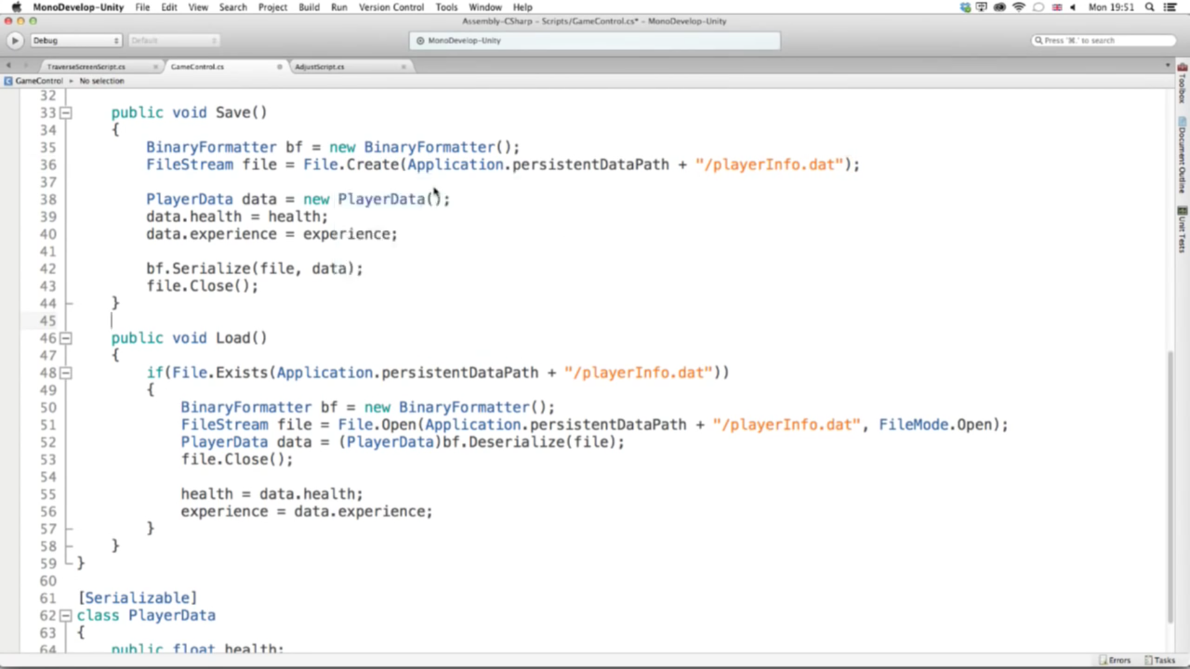
Basically the (PlayerData) needs to be there to tell it to Deserialize the player data file.
Then he sets the health and experience from the save file to the current file.

So for instance, if it were the visual novel, it would be setting the scene, the event or point in the text and any dialogue choices that have occurred that will impact the outcome of the visual novel. Also any other things of note.

He uses in his Adjust script two lines.
Gamecontrol.control.Save
Gamecontrol.control.Load
Gamecontrol is the script.
control is probably something of importance.
They will be attached to the save and load buttons.

I think that different save files can be made if I just make different file names for each save file.

He says there are far, far more ways to do this, it's just a basic way to do it, that they have shown in this video.

I have watched the video. So I'll come back to this when I begin testing save and load systems with text and several scenes.

It is highly unlikely that this will cover saving a game at a certain point in a series of events, text, scene or whatever.
I think that scene may be do able but where in the text order is difficult.
Maybe there is a way to save an instance in play mode. Who knows.

28/12/17 – Day 1: I'm going to build some test scenes that I can build a save and load system on top of.

I have built the scenes and the text/menus UI.

Now I need to add in a level manager script and game object for the scenes with a don't destroy on load in the script.

Then I can write the save/load script and game object with a don't destroy on load in the script.

Then I will add some more stuff other than scenes to test with the saving and loading system.

I'm going to do the coding tomorrow before work as the Lavie story needs Koto to come back and kick arse!

